**Task 3 – Number Range**

**Algorithm**

• Use prompt() to get a number from the user and store it in variable num.

• Convert the input string to a number using Number() or parseInt().

• Check:

* If the number is greater than 10 **and** less than 20.
* If the number is less than 5 **or** greater than 100.

• Display the results using both console.log() and alert().

**Psudocode**

START

PROMPT user for a number and store in num

CONVERT num to number type

DISPLAY entered number in console

IF num > 10 AND num < 20

DISPLAY "Number is between 10 and 20" using alert and console

ELSE

DISPLAY "Number is NOT between 10 and 20" using alert and console

IF num < 5 OR num > 100

DISPLAY "Number is either less than 5 or greater than 100" using alert and console

ELSE

DISPLAY "Number is NOT less than 5 or greater than 100" using alert and console

END

**Code(javascript)**

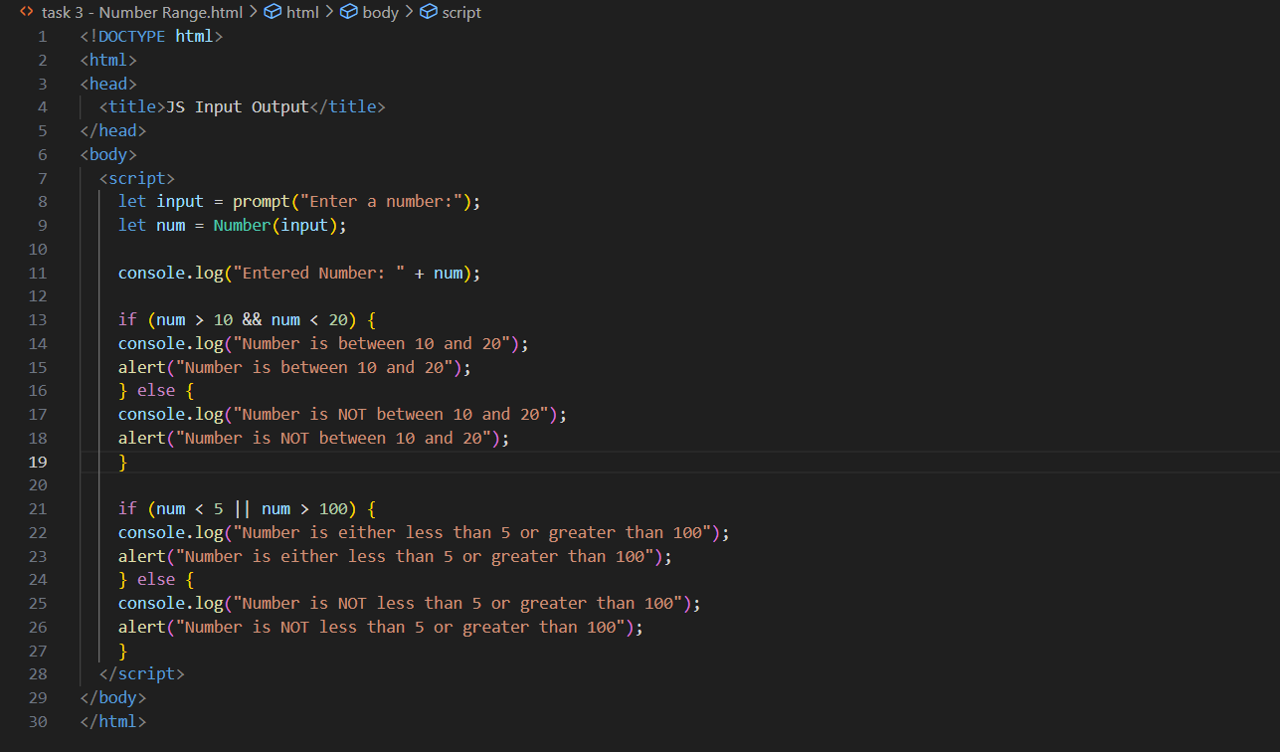

**Output (test case 1)**

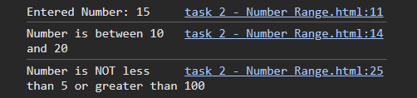

**Output (test case 2)**

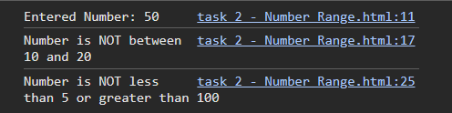

**Output (test case 3)**

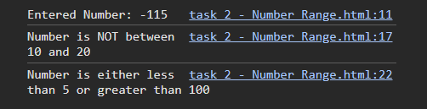

**Observations**

• The program uses **logical operators** && (AND) and || (OR) for condition evaluation.

• User input is handled dynamically and validated.

• Results are displayed clearly in **both console and alert**, helping visualize logic flow.

• This exercise builds understanding of **range checks** and logical branching.